Project Design Phase-I
Solution Architecture

Date | 27 October 2026
Team ID | Individual Project
Project Name | EV Market Performance & Insights Dashboard
Maximum Marks | 4 Marks

Solution Architecture:
Solution architecture is a complex process – with many sub-processes – that bridges the gap between business problems and technology solutions. Its goals are to:
- Find the best tech solution to solve existing business problems.
- Describe the structure, characteristics, behavior, and other aspects of the software to project stakeholders.
- Define features, development phases, and solution requirements.
- Provide specifications according to which the solution is defined, managed, and delivered.

Sample Solution Architecture Diagram:
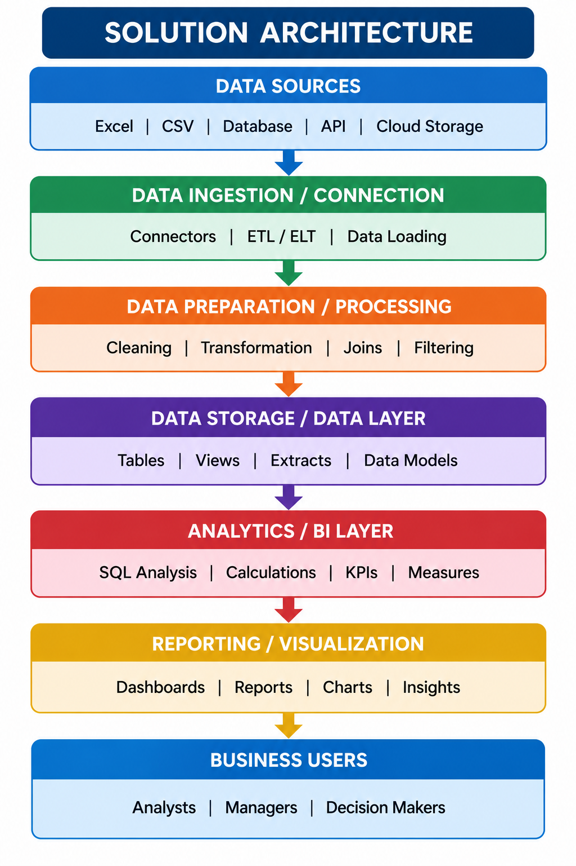

Component Description Table
Component Name | Description / Role in Architecture | Technology Used

Architecture Overview
The solution is a dashboard workflow rather than a deployed multi-tier application.
Data Layer
Structured EV vehicle dataset containing vehicle identifiers, manufacturer, manufacturing country, battery capacity and driving range fields where available.
Preparation and Analytics Layer
Tableau connects to the dataset and aggregates the relevant measures. KPI values reported in the project are approximately 199,999 distinct Vehicle Ids, 78.24 kWh average battery capacity, and 324.5 km average driving range.
Presentation Layer
Tableau dashboard displays KPI cards, vehicle counts by manufacturer, and EV counts by manufacturing country.
Publishing and Documentation
Dashboard is published on Tableau Public; workbook, README and screenshot are stored in GitHub.
Component Description
Dataset → Tableau data source → aggregations and charts → dashboard → Tableau Public; GitHub stores the workbook and documentation. No API, Snowflake database, or live ingestion pipeline is implemented.
Architecture Flow: EV dataset (source file) → Tableau data source → field selection and aggregations → KPI cards and manufacturer/country charts → Tableau Public dashboard → GitHub repository (workbook, README, screenshot).
Component Description
Component | Description
Source dataset | Structured EV records; project notes describe approximately 200,000 records and 39 columns.
Tableau data source | Connects the dataset to Tableau for analysis; no Snowflake warehouse is used in this implementation.
KPI layer | Displays distinct Vehicle Id count, average battery capacity (kWh), and average driving range (km).
Visualization layer | Manufacturer-count and manufacturing-country-count charts support category comparisons.
Publishing layer | Tableau Public hosts the dashboard at https://public.tableau.com/views/EVMarketAnalysisDashboard_17930190186570/Dashboard1
Documentation layer | GitHub stores the packaged workbook, README and dashboard screenshot: https://github.com/iamsonakshi07/EV-Market-Analysis-Dashboard

